Plastics
  - Skyport Safety Moment
Did you know?

There are 500 times more pieces of micro-plastic in the sea than there are stars in our galaxy.

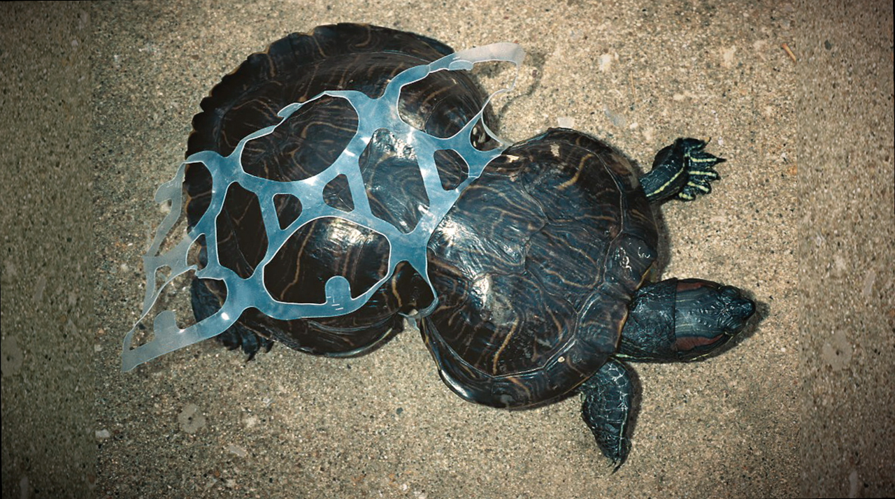
There is no such thing as “away” when we throw anything away it must go somewhere.
Cheap, strong, and durable to put it simply, plastic are designed to last….for a very long time. From cell phones and computers to k-cups and drinking straws, plastic have become a product that most of us simply can’t live without.
The problem with the “miracle” product we can’t live without is, plastic is a product our environment can’t live with. 9% of plastics get recycled, 12% get incinerated and 79% exist in landfills and our natural environment as pollution (air and water). Our marine life has suffered greatly due to plastic pollution, and the United Nations has warned we are approaching “irreversible repair.”

To reduce plastic pollution and protect our marine life we should always try to;
- Recycle
- Buy reusable containers, instead of single use plastic containers.
- Reduce
- Plastic bags are one of the biggest sources of plastic pollution, try to bring your own canvas shopping bags.
- Remove
- Work with KBB or your neighborhood to remove plastic and trash in your neighborhood, local park, or beach.
- Refuse
- When ordering a drink at a restaurant, you can let the waiter know that you won’t need a straw.

At our current rate of plastic consumption, it is estimated that by 2050 there will be more plastic then fish in the ocean. Recycle, Reduce, Remove, and Refuse plastic to change this estimated future.

